The first one designed for the WORLDWIDE and is the only one which incl. intelligent VOICE alert & best performance.

--- YOUR NO. 1 CHOICE ---

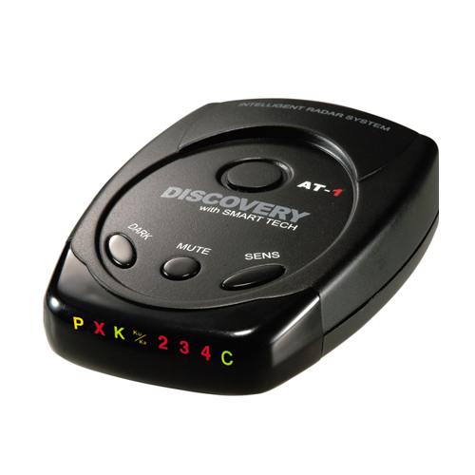

Quiet, Advanced and Versatile Ultimate Safety Radar Detector
The Discovery AT-1 has been optimized for use in the worldwide. The AT-1 includes full X, K, Ku, Superwide Ka radar system capability, front and rear LASER detection, digital signal processing (DSP) for superior range and reduced false alarms, Voice with Audio and Visual band alerts. And all the performance you’d expect from AT-1
Features Include:
- Full band detection of all EU UK police radar/laser equipments.
- Excellent performance of GATSO Photo Radar
- Clear Text Character display and real-man pronunciation Voice alert
- Separated each band’s Voice and Indicator
- Superheterodyne, GaAs FET VCO digital signal processing, Scanning Frequency Discriminator with Strength Meter indicator.
- New SpeedScan mode with virtually eliminates false alarms
- Easy mount either on the dashboard or windscreen with suction cup bracket
It real CATCHES and WARNS of SNEAKY SPEED TRAPS unlike GPS device by setting only.

